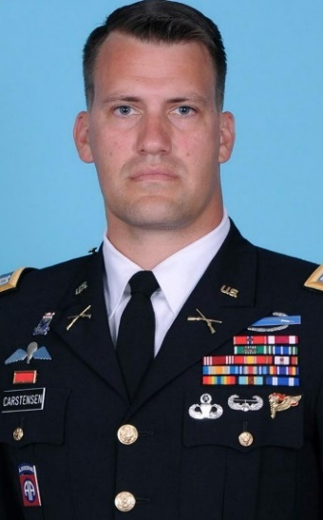
Major Matthew Carstensen is a native of Greenwich, Connecticut. After a brief stint as a student at the University of Connecticut, he enlisted in the US Army as an infantryman, deployed to Afghanistan, and earned the rank of Corporal. He then attended and graduated from the United States Military Academy at West Point with a degree in Geopolitics and commissioned as an Infantry officer.
Major Carstensen’s formative operational experience – enlisted and officer – was in high-readiness parachute units. He served in tactical leadership positions in the Arctic, coordinated combat operations at the battle-group level in both Afghanistan and Iraq, and served as the 82nd Airborne Division’s tactical nucleus for the US Immediate Response Force. Following company commands, Major Carstensen served at the Joint Multinational Readiness Center in Hohenfels Germany, where he coached U.S., NATO, and partner forces in simulated large scale combat operations. He also researched tactical integration and interoperability between U.S., NATO, and other European and regional ground combat forces, and delivered his findings regularly to Headquarters, Department of the Army at the Pentagon, as well as the International Military Staff, NATO Headquarters, Brussels Belgium. He is currently stationed at Fort Shafter, Honolulu Hawaii, where he serves as the military deputy for Strategy, Policy, and War Planning at U.S. Army Pacific. His current focus areas include theater army strategy & campaign development, contingency plan refinement, joint command & control, and setting the theater.
Major Carstensen’s awards and decorations include the Bronze Star, the Defense Meritorious Service Medal, Army Meritorious, Commendation and Achievement Medals, NATO Medal, Expert & Combat Infantryman Badges, Master Parachutist Badge, Pathfinder Badge, Air Assault Badge, and Australian Parachutist Badge. He is a graduate of the U.S. Army Command & General Staff College, the U.S. Army School of Advanced Military Studies, and the U.S. Army War College Strategic Art Program. Due to his familial, personal, and operational experiences, he speaks German and Arabic. He and his wife Taya have two sons: Rylan (13) and Quinn (10).

