 | 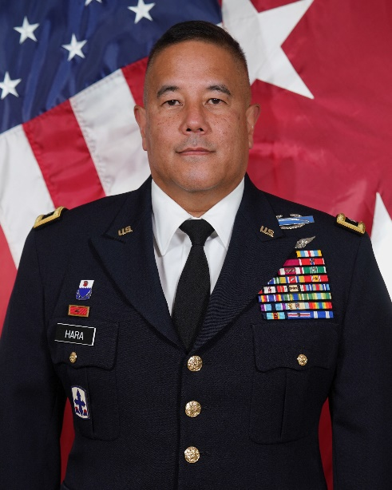
  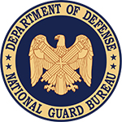 | National Guard
  Major General KENNETH S. HARA
  The Adjutant General, Hawaii
  Honolulu, HI
  Since: December 2019
SOURCE OF COMMISSIONED SERVICE OCS
EDUCATIONAL DEGREES
Hawaii Pacific University - BA - Human Services
United States Army War College - MSS - Strategic Studies
MILITARY SCHOOLS ATTENDED
Infantry Officer Basic Course
Initial Entry Rotary Wing Aviator
Combined Arms and Services Staff School
Combined Logistics Officer Advanced Course
United States Army Command and General Staff College
United States Army War College
Dual Status Commanders Course (NORTHCOM)
Joint Task Force Commanders Course (NORTHCOM)
Army Strategic Education Program - Basic (ASEP-B)
General and Flag Officer Homeland Security Executive Seminar (GFOS)
Army Strategic Education Program - Advanced (ASEP-A)
FOREIGN LANGUAGE(S) None Recorded
PROMOTIONS | DATE OF APPOINTMENT
2LT | 26 Jul 87
1LT | 25 Jul 90
CPT | 8 Mar 93
MAJ | 20 Apr 00
LTC | 3 Jun 04
COL | 8 Dec 08
BG | 15 Oct 15
MG | 6 Dec 19

FROM | TO | ASSIGNMENT
Dec 19 | Present | The Adjutant General, Hawaii, Honolulu, Hawaii
Oct 15 | Dec 19 | Assistant Adjutant General, Honolulu, HawaiiI; dual-hatted, February 2018 - December 2019, Deputy Chief of Staff, Army National Guard, Operations/G3, Wartime, Eighth United States Army, AP
Jan 14 | Oct 15 | Chief of the Joint Staff, Joint Force Headquarters - Hawaii, Hawaii National Guard, Honolulu, Hawaii
Jan 12 | Jan 14 | Commander, 29th Infantry Brigade Combat Team, Kapolei, Hawaii and Kandahar, Afghanistan
Jun 08 | Jan 12 | Deputy Commander, 29th Infantry Brigade Combat Team, Kapolei, Hawaii and Kuwait
Jul 07 | Jun 08 | Student, U.S. Army War College, Carlisle Barracks, Pennsylvania
Dec 06 | Jul 07 | Branch Chief, Joint Force Headquarters-Hawaii, Kapolei, Hawaii
Sep 06 | Dec 06 | Commander, 1st Squadron, 299th Cavalry, Hilo, Hawaii
Oct 04 | Aug 06 | Commander, 2nd Battalion, 299th Infantry, Hilo, Hawaii and Baghdad, Iraq
Aug 03 | Oct 04 | Executive Officer, 103rd Troop Command, Pearl City, Hawaii
Jan 02 | Aug 03 | Commander, Regional Training Site Maintenance, Ordnance Training Company, Pearl City, Hawaii
Dec 99 | Jan 02 | Assistant S3, 29th Separate Infantry Brigade, Kapolei, Hawaii
May 99 | Dec 99 | Detachment Commander, Headquarters and Headquarters Detachment, 103rd Troop Command, Pearl City, Hawaii
Jul 97 | May 99 | Training Security Officer, 103rd Troop Command, Pearl City, Hawaii
Jan 95 | Jul 97 | Base Defense Liaison Officer, 25th Infantry Division (Light) Detachment, Pearl City, Hawaii
Oct 91 | Jan 95 | S3 Air, 2nd Battalion, 299th Infantry, Hilo, Hawaii
Sep 91 | Oct 91 | Aviation Section Leader, 452nd Aviation Detachment, Hilo, Hawaii
Jul 91 | Sep 91 | Aviation Section Leader, 451st Aviation Detachment, Hilo, Hawaii
Jan 91 | Jul 91 | Chemical Officer, Headquarters and Headquarters Company, 2nd Battalion, 299th Infantry, Hilo, Hawaii
Jul 90 | Jan 91 | Executive Officer, Company A, 2nd Battalion, 299th Infantry, Keaau, Hawaii
Sep 88 | Jul 90 | Platoon Leader, Detachment 1, Company A, 2nd Battalion, 299th Infantry, Pahala, Hawaii
Jul 87 | Sep 88 | Platoon Leader, Company A, 2nd Battalion, 299th Infantry, Keaau, Hawaii
Jun 86 | Jul 87 | Officer Candidate School, Hawaii Military Academy, Waimanalo, Hawaii

SUMMARY OF JOINT ASSIGNMENTS |  | DATE | GRADE
Assistant Adjutant General, Honolulu, Hawaii  Chief of the Joint Staff, Joint Force Headquarters - Hawaii, Hawaii National Guard, Honolulu, Hawaii  Commander, 29th Infantry Brigade Combat Team, Kapolei, Hawaii and Kandahar, Afghanistan |  | Oct 15 – Dec 19  Jan 14 - Oct 15  Jan 15 – Dec 19 | Brigadier General  Colonel  Colonel

SUMMARY OF OPERATIONAL ASSIGNMENTS |  | DATE | GRADE
Commander, 29th Infantry Brigade Combat Team, Kandahar, Afghanistan |  | Nov 12 - Jul 13 | Colonel
Deputy Commander, 29th Infantry Brigade Combat Team, Kuwait |  | Oct 08 - Jul 09 | Colonel
Commander, 2nd Battalion, 299th Infantry, Baghdad, Iraq |  | Jan 05 - Jan 06 | Lieutenant Colonel
US DECORATIONS AND BADGES
Distinguished Service Medal
Defense Superior Service Medal
Legion of Merit
Bronze Star (with 1 Bronze Oak Leaf Cluster)
Meritorious Service Medal (with 3 Bronze Oak Leaf Clusters)
Army Commendation Medal (with 1 Silver Oak Leaf Cluster)
Army Achievement Medal (with 2 Bronze Oak Leaf Clusters)
Meritorious Unit Commendation (with Bronze Oak Leaf Cluster)
Army Reserve Components Achievement Medal (with 1 Silver Oak Leaf Cluster)
National Defense Service Medal (with Bronze Service Star)
Afghanistan Campaign Medal (with Campaign Star)
Iraqi Campaign Medal (with 2 Campaign Stars)
Global War on Terrorism Expeditionary Medal
Global War on Terrorism Service Medal
Humanitarian Service Medal
Armed Forces Reserve Medal (with Silver Hourglass Device and "M" Device)
Army Service Ribbon
Overseas Service Ribbon (with Numeral 3)
Army Reserve Components Overseas Training Ribbon (with Numeral 5)
North Atlantic Treaty Organization Medal
Combat Infantryman Badge
Army Aviator Badge
FLIGHT INFORMATION
Rating: Army Aviator
Flight hours: 196.6
Aircraft flown: UH-1H
Pilot wings: 04 Jun 1991
CIVILIAN OCCUPATION
The Adjutant General for the State of Hawaii, Department of Defense located in Honolulu, Hawaii. As a cabinet member, serves as executive head of the state Department of Defense, commanding general of the militia of the state. The department includes the Hawaii Army National Guard, Hawaii Air National Guard, Hawaii Emergency Management Agency, Office of Homeland Security, Office of Veterans Services, and the Youth Challenge Academy. Appointed as the state’s overall COVID-19 incident commander from March 2020 to March 2022. Appointed as the state’s overall incident commander for the Maui Wildfire Response from August 2023 to present.
PROFESSIONAL MEMBERSHIPS AND ACHIEVEMENTS
National Guard Association of the United States
Adjutants General Association of the United States
Hawaii National Guard Association
Hawaii Pacific University Alumni Association
Association of the United States Army
National Infantry Association
United States Army and Cavalry Association
OTHER ACHIEVEMENTS
2017, Joint Qualified Level III
2011, Hawaii National Guard Field Grade Commander of the Year - Hawaii National Guard Association
2001, Hawaii Army National Guard Outstanding Officer of the Year - Hawaii National Guard Association

As of: 24 Jan 24

