May 2025
Hawaii National Guard Unit Public Affairs Representative Handbook
National Guard Bureau Public Affairs Office
Updated by State PAO, State of HI, Department of Defense
Table of Contents
Executive Summary 3
About the Handbook 4
Appointing Unit Public Affairs Representatives 5
Supporting Your UPAR 6
Time 6
Support 6
Policy 7
DoD Policy 7
SAPP - Security, Accuracy, Propriety and Policy 7
OPSEC - Operational Security 8
Copyright and Fair Use of Your Products​ 8
FOIA -​ Freedom of Information Act 8
UPAR Responsibilities 9
Beginner Responsibilities 9
1. Create a Public Affairs Plan 9
2. Public Affairs Liaison ​ 9
3. Take Photos, Write Captions and Get Published 9
4. Record Basic Video 9
Intermediate Responsibilities 10
5. Media Escort and Preparation 10
6. Media Relations 10
7. Command Information 10
8. Writing The Story 10
1. Create a Public Affairs Plan 11
2. Public Affairs Liaison ​ 14
3. Take Photos, Write Captions and Get Published 15
Taking Photos 15
Writing Captions 21
Getting Published 23
4. Record Basic Video 24
5. Media Escort and Preparation 25
6. Media Relations 27
Special Circumstances 28
Different Types of Media 29
Public Affairs Guidance 29
Command Messages/Talking Points/Themes 30
Hints For Media Interviews 31
7. Command Information 33
Unit Newsletter 34
Social Media 35
8.Writing the Story 37
News Story 37
Feature Story 40
UPAR VS PA Specialist 42
Getting Support 43
Contact Info 43
Social Media Accounts 44
Associated Press Rank Abbreviations 45
Additional Duty Appointment Sample Memo 46

Executive Summary
This handbook is broken into three key sections when it comes to information on Unit Public Affairs Representative, otherwise known at UPAR.
First is background information on the best way to utilize this handbook. Ideal to double check your knowledge and to reference the details. When it comes to picking a UPAR, commanders want to look for knowledgeable, trustworthy, and well-spoken individuals to represent the unit. To set the UPAR up for success, commanders must give time and support to the representative as they learn and grow into the role. Additionally, there is a lot of policy that underpins public affairs, which in succent form says share accurate information, but be mindful to be professional and not overshare.
The next section looks at the UPAR responsibilities, which have been subdivided into beginner and intermediate skill levels. The first responsibility is to create a public affairs plan by meeting with the commander to set goals and schedule the workload. The next responsibility is to be a public affairs liaison which is essentially being the point of contact for all things relating to public affairs. The third responsibility is the most important which is to ​take photos, write captions and get them published. ​Being able to record basic video which would be a series of short clips is the fourth and final beginner responsibility. The fifth responsibility and first intermediate skill is to escort the media and help prepare the unit for when the media visits. The next responsibility relates to media relations, by understanding the media and helping prepare for interviews​. Communicating to members of the command​ with command information through newsletters or social media is the seventh responsibility. The final responsibility is to write stories which may be in the format of a news story or a feature story.
Finally, the last section of the handbook looks at the differences between a UPAR and Public Affairs Specialist or Officer with the latter being more advanced and knowledgeable. Then the different ways a UPAR can get support from additional resources to people to contact.
All sections have key points for commanders to know highlighted in green for brevity.

About the Handbook
The handbook has been written to bring public affairs tasks to the UPAR realm. The handbook is a starting point, a tool to help you “break ground” in the field of public affairs. Get to know the full-time Public Affairs Office (PAO) in Hawaii State Headquarters (808) 441-7000 and establish a relationship with other public affairs unit members (117th Mobile Public Affairs Detachment in the 103rd Troop Command or the Brigade PAO in the 29th IBCT or in the Hawaii Air National Guard Headquarters, 154th Wing Public Affairs).
You can't avoid public affairs (PA), it's all around you and in your dealings with the members of your unit and the community. Public affairs doesn’t only happen when you're talking with a reporter. It is an all-encompassing effort with a goal of ensuring your unit is nested in messaging with your higher command and the Hawaii National Guard is well-accepted and supported in the community.
The Hawaii State PAO and its full-time staff cannot be everywhere at once. There are numerous newsworthy events that occur during drill, exercises, annual training and during real-world missions in Hawaii and abroad that cannot be covered by trained PA specialists. We need UPARs to help tell the Hawaii National Guard (HING) story and share our successes with our local community and the world.
The Adjutant General understands and supports good public affairs planning. It is done at his level, and it is expected that all under his command will apply good public affairs as well. The best chance of establishing and maintaining good will and public acceptance, which is essential for your unit to be combat ready and succeed, is by exercising key elements of public affairs.
This handbook is designed to simplify your public affairs efforts. It provides you a reference for dealing with public affairs issues and stresses the importance of preparation and practice. The handbook will not make a UPAR a public affairs expert, but it can help make a UPAR’s work easier and more effective.
The following sections will explore how a commander should pick the UPAR and what ways a commander can support the UPAR. Then discuss the policy and guidance on public affairs. Finally details on eight key components every UPAR will learn, with the first four being basic and the last four being intermediate. There are additional resources available at the end of this handbook, but your best learning tool will be practical experience and on the job training.

Appointing Unit Public Affairs Representatives
When commanders are appointing a person as the UPAR, consider the following roles, responsibilities, and expectations to guide the choice:
- The UPAR should be someone who is familiar with the unit, its leadership, and overall mission.
- The UPAR must be well-organized and independent. Leadership does not have time to closely supervise someone's work. The UPAR appointee should have proven themselves as dependable during past missions.
- The UPAR should be able to communicate well, speak clearly and effectively to unit members or reporters if needed. They will need to accurately write captions and possibly short stories highlighting the unit and its members.
- The UPAR should have a smart phone with a camera and basic knowledge on how to use it.
- The appointed person should hold the UPAR position for a minimum of two years.
- The UPAR will need to attend the Basic UPAR Training (3-hrs) in the first year of their appointment and the Intermediate UPAR Training (2.5-hrs) in the second year of their appointment.
- Do not send the newest Soldier/Airman in the unit to the class. Do not send someone to just fill the slot. If no effort is made in the UPAR selection, units will get that same output by the UPAR. Do not force someone to be the UPAR. This person will have the ability to speak for your unit, write and take pictures of your missions.
The Hawaii State PAO is responsible for training and tracking all HING UPARs. Hawaii Army National Guard (HIARNG) and Hawaii Air National Guard (HIANG) units will send their UPARs to the classes, then support their UPARs throughout their term. Units will be notified if they are delinquent with their appointment memos, basic UPAR class, and Intermediate UPAR class completion.
The 117th MPAD and the 154th Wing PA can also provide UPAR training. Provided those trainers are vetted by and the training coordinated through the Public Affairs Specialist in the Hawaii State PAO.

Supporting Your UPAR
UPARs will need at least two important things from the commander and the unit:

Time
This may be the most important element that a commander can provide a UPAR. Time to meet with the UPAR to plan and initiate the unit’s PA Plan.
It takes a while to get established as a UPAR, and time to become efficient. After training, UPARs need experience to grow their new skills. Commanders should allow for a period of adjustment while the UPAR learns the job.
It also takes time for a UPAR to plan and carry out tasks post-event. Production time after a mission is especially important for major projects such as an open house, Family Readiness Group event, a promotion, retirement or change of command ceremony. Commanders and NCOs should include this time when PA Planning.
The UPAR will need time to be a productive member of the unit within their primary mission, but also have time to cover unit activities and complete the final step: getting their products to the next public affairs echelon.

Support
The unit’s staff need to know the UPAR and be aware that command supports the UPAR's efforts. UPARs should attend appropriate staff meetings, get training schedules emailed to them and be included in the planning process for unit events and training.
A good UPAR is very much “in the know” regarding a unit's schedule. Post the UPAR's name prominently on your bulletin board, mention them and their capabilities at pre-drill meetings and encourage unit members to talk with the UPAR about possible newsworthy events.
The need for supplies will vary, but if you're planning to have a UPAR publish a unit newsletter, that UPAR will need commander’s intent, goals and objectives, access to a computer, and the ability to get photos loaded onto that computer. The UPAR should have assistance with content creation and collection. They cannot do it alone. Cell phone cameras are acceptable for an UPAR. Assistance can be provided by the Hawaii State PAO.

Policy
Some key policies and their implications that UPARs need to beware of are below.

DoD Policy
Effective communication is required at the core of all government organizations​. A free flow of general and military information will be made available without censorship or propaganda​. Information will not be classified or otherwise withheld to protect the Government from criticism or embarrassment​.
Information will be withheld only when disclosure would adversely affect national security, threaten safety or privacy of the Armed Forces, or otherwise as directed by law or regulation. Standalone or combined portions of classified and unclassified information have the potential to compromise classified information or disclose operations security​. It’s critical that information intended for public release is first cleared via a security and policy review, usually conducted by public affairs​.
Some Key points from the DoD policy to keep in mind include:
- The obligation to provide the public with information on major programs may require detailed public affairs planning and coordination within the DoD and other agencies​.
- Propaganda has no place in DoD public affairs.
- Disseminate accurate information to the intended audience​.
- Increase public awareness to the organization’s mission, goals, policies and programs.
- A good PA program helps to foster community relations and can build ​good will.
- The release of accurate information must be done with speed, efficiency and through a variety of mediums​.
- We are accountable to taxpayers and rely on their support.
- Be cautious when giving out information about members of your unit. A federal law called the Privacy Act is designed to protect the privacy of everyone and limits the types of information which you may provide about an individual.

SAPP - Security, Accuracy, Propriety and Policy
Security​ | Is there an OPSEC concern? Protect your team​.
Accuracy​ | Is the information correct and true? Don’t spread misinformation​.
Propriety​ | Is it in good taste? Be professional and respect privacy rights​.
Policy | Do not violate DoD policy, if you don’t know then ask. This goes together with operations and personnel security​. Monitor the information environment and balance releases to print media, television, social media, etc.

OPSEC - Operational Security
Under no circumstances may classified information be released. Do not provide any comments on matters which are or may be classified. If you know that information being sought is classified, indicate just that and decline to comment on that topic, in a direct manner. If you're not certain whether something is classified, find out before you respond then, act accordingly. All personnel must be aware of OPSEC and be responsible for safeguarding sensitive information​. The catch-all: “You need to speak to my PAO.”
Key points to keep in mind include:
- Do not share the exact number of troops, exact times of departure, radio frequencies, which vehicles are mission ready, what route a unit will take, etc.
- Do not share social security numbers, birth dates, contact information, etc.
- Adhere to Security, Accuracy, Propriety and Policy
- All DoD employees must practice security at the source​.
- OPSEC applies to media interviews, sharing information and imagery with family and friends, including email and social media platforms​.
- Prevents unauthorized disclosure of information that could degrade operational effectiveness.

Copyright and Fair Use of Your Products​
If you are a service member, working with government equipment, and/or on government time, on Title 32 status (drill, AT or School), you cannot copyright your work. It belongs to the government.

FOIA -​ Freedom of Information Act
This act allows a member of the public who follows the rules established by proper authority in the Department of Defense to request a record without it being withheld in whole or part unless the record is exempt from mandatory partial or total disclosure.
Understand that the law is designed to prevent government agencies, including the military, from withholding its documents in response to a legitimate request from a reporter or other individual, even if the information is potentially embarrassing. The HIARNG has a FOIA POC assigned, UPARs may assist in gathering info but will never lead FOIA responses. With this mind do not forward (via email) negative, incident, accident or inappropriate photos.

UPAR Responsibilities
The responsibilities of a UPAR are broken up into beginner and intermediate, with the beginner responsibilities learned in the first year and intermediate responsibilities learned in the second year. Each section will explore in detail what is expected and provide examples to reference.

Beginner Responsibilities

Create a Public Affairs Plan
Meet with your commander and establish a unit public affairs plan. This would include setting quarterly goals (such as a newsletter, coverage of upcoming events, submissions to higher PA elements). That means being aware of yearly training plan/brief and monthly training schedules. Write out a plan, revise and revisit the plan as needed. This will be the UPAR’s guide and direction from commander.

Public Affairs Liaison ​
Be the public affairs liaison between the commander and the PA Office or higher PA elements. Serve as the public affairs point of contact or liaison for unit. UPARs should become Subject Matter Experts (SME) about their unit and must have access to information and leadership. When information is needed from higher PA elements, UPARs will be the first who are contacted. Being a liaison will come into play when media visits the unit.

Take Photos, Write Captions and Get Published
The primary function that every UPAR needs to do is to take a good photo, write a caption for it, and then get it to the next PA echelon. This task is the minimum requirement for a functioning UPAR. With that photo, the Hawaii State PAO can use it many ways to tell the HING story. It can be sent to local media, published on the TAG’s Facebook, X or Instagram page, used in slideshows, and if good enough, sent to the Defense Visual Information Distribution Service or DVIDS. On the DVIDS website, media and the public can join and download military imagery, videos, and stories for free to use in their newscasts or publications.

Record Basic Video
There are many similarities when shooting photos and recording video, UPARs will be able to record video for social media and short clips of B-roll that can be used by higher PA elements for distribution.

Intermediate Responsibilities

Media Escort and Preparation
Provide a media escort to reporters that visit your armory or training sites. Prepping the unit for the visit by preparing the SMEs for interviews, finding locations to visit and generating talking points are key parts. The UPAR will also ensure OPSEC is observed, but it is everyone’s responsibility too. When the media arrives at the unit, the commander should be informed of their arrival and the UPAR should be the first to greet them and facilitate reasonable requests.

Media Relations
Media relations includes how we communicate with the media, interview prep and techniques to ensure we get our message effectively communicated. UPARs will learn how to use Public Affairs Guidance, command messages/talking points, and techniques for media interviews. At times the Hawaii State PAO will need information for media releases and advisories which UPARs may be asked to provide. UPARs are not PAOs but can assist PAOs in many ways.

Command Information
A method of communicating mission essential information to members of the command. The UPAR should be prepared to cover unit participation in community projects, promotions, award ceremonies, changes of command and many others. All these events can potentially be shared on social media, newsletters, or posters/flyers. What gets covered and how it gets published should be established with the commander when the UPAR develops the unit’s PA Plan.

Writing The Story
Learn the basics of writing a news story and a feature story. In addition to understanding what is newsworthy, learn what should be published at their unit level and what should be sent higher for release.

Create a Public Affairs Plan
Meet with your unit commander and establish a unit public affairs plan. Start with looking at yearly training plan/brief and monthly training schedules. Look at drill highlights, special training or exercises. Pitch possible ideas and make the plan together. Look at the events planned for the year and be sure to get a point of contact for information on the event and coordinate logistics. Being prepared means having a schedule.
Big events such as annual training can provide a lot of content. A great way to figure what kind of things you should be looking for is to check out other unit’s social media and see what they have posted. By writing out a plan, revising and visiting the plan as needed, you’ll be set up for success. Additionally keeping the public affairs plans fluid will allow you to keep adding to it as new situations arise.
Example Public Affairs Plan
October | Social Media Post - Weapons qualifications  - Take photos, get best scores and new shooters​  - Write caption  - Send to higher PA elements for social media posting  Dec Newsletter  - Start designing layout and looking at past socials for story ideas
November | Social Media Post – New PT test  - Take photos, get best scores and most improved​  - Write caption  - Send to higher PA elements for social media posting  Dec Newsletter  - Draft content and pics  - Get Commander to write a column​  Coordinate with higher PA, about new equipment  - Reach out to contact with story idea and details (5 W’s)  Holiday party  - Contact committee to get event details
December  December | Social Media Post - Mandatory Classes  - Take photos  - Write caption  - Send to higher PA elements for social media posting  Dec Newsletter  - Do final draft  - Get commander approval  - Distribute newsletter  Holiday party  - Take photo  - Write a story  - Send to higher PA elements for social media posting
Annual Training | Social Media Post - New equipment  - Take photos  - Write caption  - Send to higher PA elements for social media posting  Social Media Post - Soldier’s first AT  - Take photos  - Write caption  - Send to higher PA elements for social media posting

Release authority, otherwise known as approving photos, captions or newsletters to be published, is an important step. At the unit level this would be the commander who gives the release authority to the UPAR to publish unit projects such as the unit newsletter. Keep your commander apprised of UPAR activities and products. Your commander is the UPAR’s first release authority. Nothing should be released to the public domain without the commander’s approval.
For all official unit social media posts, release authority belongs to a public affairs officer- for drills (State PAO) and during exercises or deployments, first PAO in chain of command.
During real world events, exercises or training events, establish communication with the higher PA Echelon — 29th IBCT PAO, 117th MPAD or 154th Wing PA, as they will approve all products and be the release authority. The Hawaii State PAO will be your full-time higher PA element. The Hawaii State PAO oversees and provides all UPAR training and serve as PA SME. During State Active Duty missions there may be a HING Task Force PAO, but you can always contact the Hawaii State PAO.
Levels of Public Affairs Information Sharing (HIDOD SOP, not a national thing)
Level 1 | Unit level | Examples: Unit newsletter
Level 2 | MSC’s Level | Examples: HIARNG, Recruiting, MedDet, 29th IBCT, 103rd TC, 298th MFTR social media
Level 3 | Hawaii State PAO | Examples: TAG, DAG, CSEL social media, HIDOD PowerPoints, Pupukahi newsletters, DVIDS or media releases
Level 4 | Media or National | Examples: Any media outlet (TV, online, newspaper), DoD, NGB, INDOPACOM, Big Army or Big Air Force, USARPAC

What should come out of a PA Plan?
- The Commander’s intent and objectives​.
- The Commander’s priorities, the command messages​.
- What will be covered by UPAR during drills and annual training​.
- When is release authority given​, Every photo needs approval, quotes need approval, newsletter needs approval, etc.
- When to request PAO​ support.
- Expectations and evaluation of content produced.
- Discussions and commitment by Command on time and support levels needed to succeed.

Public Affairs Liaison ​
A liaison is a person who helps different organizations or groups to work together and provide information to each other. In the UPAR’s case, they would be the PA liaison between the commander and the PA Office or higher PA elements. Additionally, there would be the public affairs point of contact or liaison for the unit.
UPARs should become SMEs about their unit and must have access to information and leadership. They will provide counsel to the commander and higher PA as needed. This will not happen overnight, takes time to build expertise and trust the counsel given.
When information is needed from higher PA elements, UPARs at the lower units will be the first contacted. In that case, information is “pulled” up the chain. In cases when UPARs forward on stories or pictures to higher PA elements the information is “pushed”. Pushing and pulling of information should be balanced.
UPARs will immediately notify PAO of any issues that might gain national or international media attention (accidents/investigations). The UPAR will also come into play when media visits the unit as the first person to meet the media, responsibility number five will provide additional details.

Take Photos, Write Captions and Get Published
The primary function that every UPAR needs to do is to take a good photo, write a caption for it and then get it to the next PA echelon. With that photo, the Hawaii State PAO can use it many ways to tell the Guard story. It can be sent to local media, published on social media, used in high-level slideshows, and if its good enough, sent to the Defense Visual Information Distribution Service (DVIDS). On the DVIDS website, media and the public can join and download military imagery, videos, and stories for free, to use for their newscasts or publications.
Some ideas of what might be good to photograph, video or write about:
- State emergency activation
- Unusual training programs
- Change to your unit's equipment, force structure, or mission
- Visits by well-known personalities
- Public service projects involving the community
- Charitable work by individuals
- Drug demand reduction programs
- Major awards, honors, or individual achievements
- Unit open house
- Interesting new equipment or aircraft
- Overseas deployments for training
- Cost saving solutions
- Events that have an impact on the local environment
- Annual training for your unit
- Changes of command
- Officer and NCO academy graduations
- Presentation of awards and decorations to your unit or individual members
- Participation in competitions such as marksmanship contests, marathon races, biathlons, or other events
- Involvement in youth programs
- Construction or significant remodeling/repair of military facilities in your area
- Changes to recruiting/retention benefits

Taking Photos
Good photographs must meet certain technical standards. A photo must be in sharp focus — no exceptions. The photo should have a good range of contrasts, that means it should not look washed out, the colors should be rich and vivid. The photo must have eye appeal, it should grab your attention.
A photo serves the purpose of illustrating the story you are telling. If your story is about a change of command, a good head and shoulders picture of a new commander illustrates the story, better than a group picture of the unit's senior leadership, or the customary "passing the flag" picture. If your unit has received new equipment, take photos of the equipment in action, not resting on the armory floor.
Any subject (a person, equipment) or training area can be photographed in an unlimited number of ways. Each picture will give a different impression of the subject. Close-ups can be powerful images. Taking a photo at an unusual time or day or during stormy weather can add impact to a photograph. A good photographer needs to develop their ability to observe the action and decide how best to tell a story with one or more photographs. Be willing to experiment, to practice and ask for help from professionals.
When your taking photos remember:
- Get as close as possible to the action, but do not interfere or restrict movement with your presence. Don’t get in the way of the mission or compromise safety in the process​. Practice doing a run through scenario of “getting close to the action.”
- Pictures should be in focus. To focus on your subject with a smart phone camera tap on the screen where you want to focus, such as people’s faces.
- Take multiple photos, you can always delete extras later, but you can’t recreate a moment. Burst mode is a useful feature on your phone to take many photos at once. Review your photos when the event is over, you don’t want to miss the perfect moment because you’re looking back at the images​.
- Prepare ahead of time, by charging your phone and having enough storage space for photos and video.
Tips for taking pictures with a smartphone:
- Make sure your phone doesn’t have geo tagging on, keep OPSEC in mind.
- High Dynamic Range, a HDR photo is created by balancing the shadows and highlights of an image so that neither is being favored or ignored. This can help with situations that are low light.
- Turn off camera sound, so there’s no noise when taking photos.
- If possible, use airplane mode when taking photos eliminates a lot of concerns.
- You can add gridlines to the screen of your smartphone under settings. Gridlines help with composition of photo, by showing the spacing. Divide any composition into thirds, vertically and horizontally, and then place the key elements of your image along these lines or at the junctions of them. The arrangement achieved will be more interesting, pleasing and dynamic; this is the rule of thirds.
- Turn-off any “live” photo feature that your phone may have.
General tips when taking photos:
- Look for informal or unrehearsed scenes, posed pictures look "posed". Since you can't always take pictures without others noticing, spend a few moments with your subjects to put them at ease. You can begin shooting before the person starts jumping or moving through the scene.​
- Avoid taking too many shaka photos, some are fine but no more than two for any event.
- Beware of things in the background of your photos. Is a tree branch or howitzer barrel "growing" out of the back of the head of your subject? Be aware that it is hard to see troops in camouflaged uniforms when they are posed against trees and shrubs. Shoot from a lower angle and make the sky your background, or search for other viewpoints that reduce the chance your subjects will blend into the background too much.
- Take a few moments for a check of your subjects. Are they in a proper military uniform? Are they working with equipment or weapons in an approved and safe manner? Do they have on all the PPE that they are required to have on?
- Don't crowd a photograph with people or subjects.
- In sizing the photo, you want to be able to see faces and patches.
- Speed is important. Your photos and captions should be delivered quickly. Get them to your release authority, the approval process should not take a long time. If there is a tight deadline, let the release authority person/unit know.
- Every photograph must have a caption. Take care to ensure that names are spelled correctly and that equipment or the action in the photo is adequately described. Keep a note pad on hand to have people write in their rank, name, unit and MOS. After the photo take a picture of the names to track who’s who. Get the 5W’s (Who, What, Why, When and Where)
- During ceremonies and formal events remember that people may be behind you or to the side of you. During these situations try not to photobomb other photographers or videographers. Attend the rehearsal to figure out placement and plan some shots you’d like to take.
Photo Angles
Eye Level​ | A smartphone is placed at the same height as the eyes of the subject in your frame. | 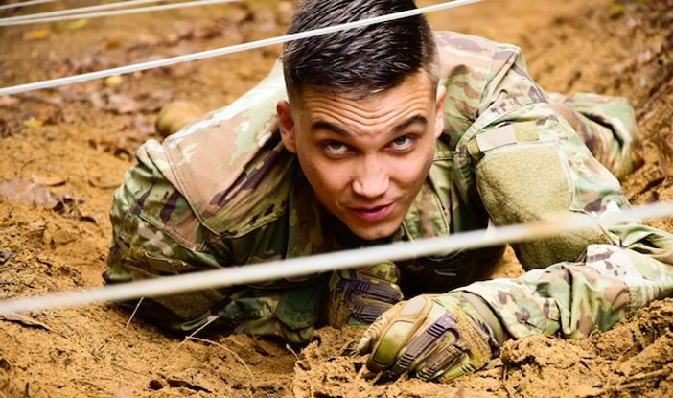
Top View​ | Where the smartphone looks down on the subject. | 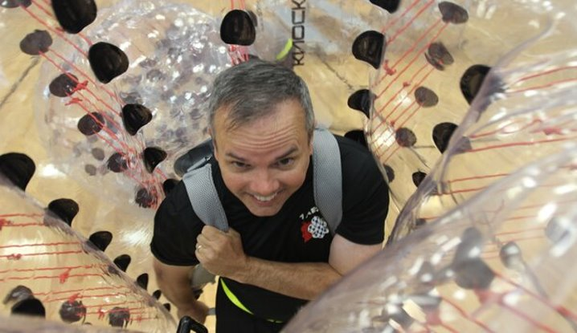
High Angle​ | Placing the smartphone high about your head angled down on your subject. | 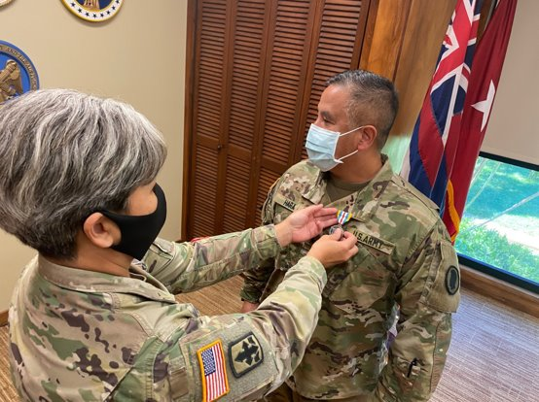
Framed View​ /Hidden View | Can be set and framed in any shot size you like, if there is only one character featured within the frame. | 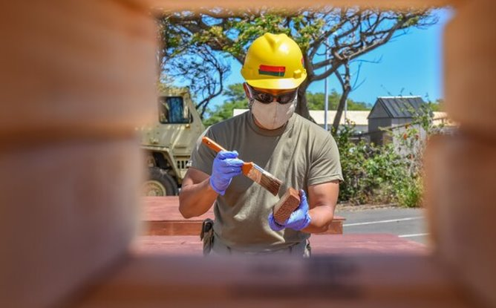
Off-Center​ | Space in front of the subject. | 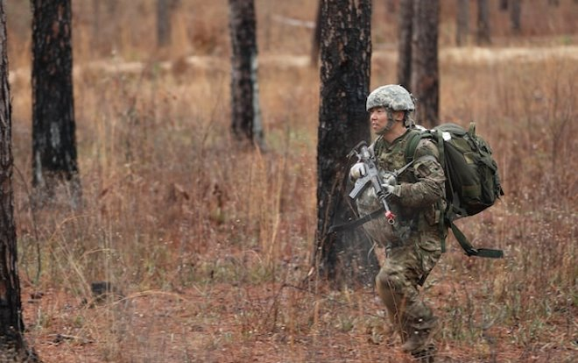
Low Angle | Conveys several emotions or feelings about the subject in the frame. | 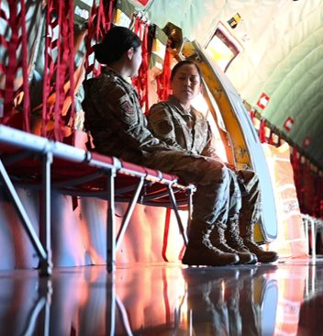
Action | Capturing the subject in motion. | 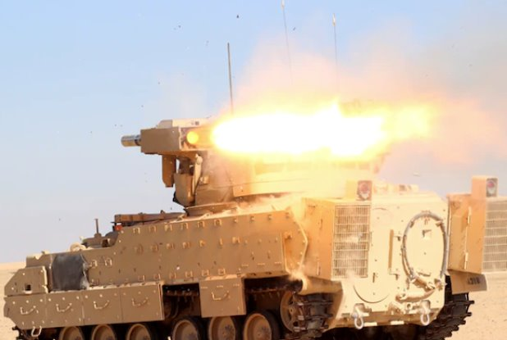
​ Posed | Constructed by the photographer and are often controlled. | 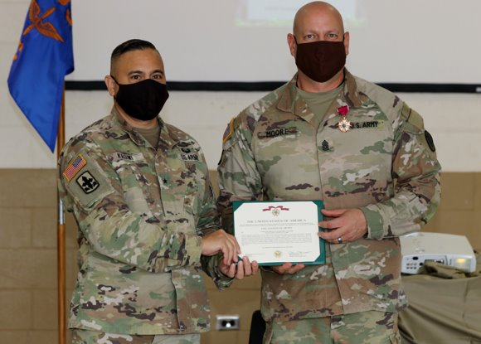
Focal Point | The point at which all elements or aspects converge; center of activity or attention. | 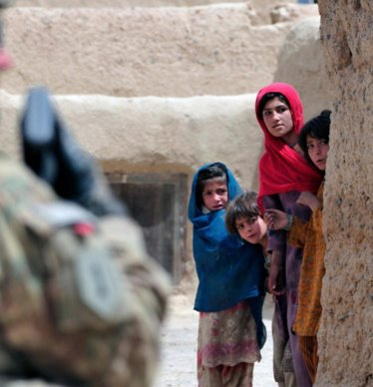
Candid | A photograph captured without creating a posed appearance. | 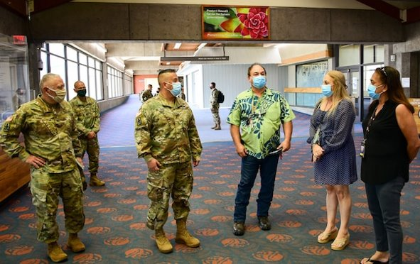

Series of Photos
A series of photos can tell a story by varying the angle and the distance. Photographers should take a variety of shots when covering an event. Long shots establish the scene and show the reader the big picture. There does not need to be identifiable people in these shots. Medium shots show one or two clearly identifiable people doing something. Try to get at least a three-quarters view of the person and make sure you can see the eyes. Most of your shots should be medium shots. Close-ups focus on the center of the action and include only one person. When fitting the person and action into the frame, called cropping, make sure you do not cut them off at the joints. For examples if showing the face, cut above the eyes and below the mouth. If showing the hands at work, cut in the middle of the hand or include the wrists.
Establishing Shot  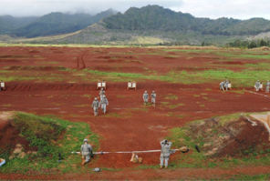 | Long Shot  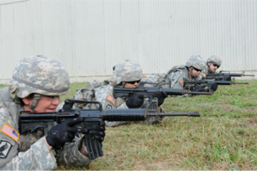
Medium Shot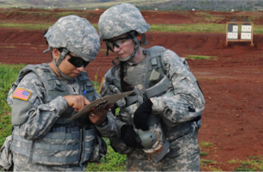 | Close-Up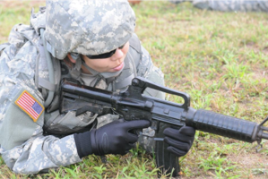

Writing Captions
A caption is an explanation of what is going on in a photograph and why it is important to the audience. Captions should be short and clear, typically 1-3 sentences, they can highlight technical information. The caption will influence the meaning of the photo, so make sure it complements the picture.
Basic Elements of a Caption
Who | Who is in the photo? Who is the subject of the photo?​  Full ID (Rank, Name, Unit and MOS) If less than three people in photo​.
What | What is in the photo? What is the action taking place? ​
When | When is the action taking place? (date, training event)​
Where | Where is the action taking place? (geographic location)​
Why | Why is the action taking place? Why does it matter?​
Byline | Photo credit
How | If possible, explain how?

Example Caption
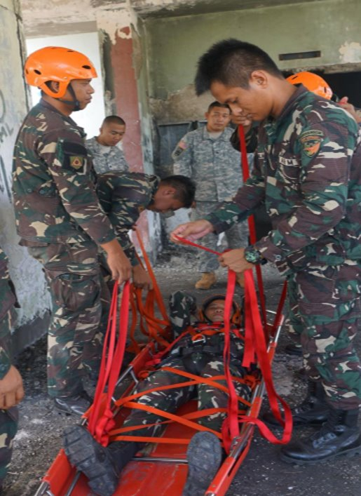
Members of the Armed Forces of the Philippines, 525th Engineers, demonstrate patient packaging during a subject matter expert exchange in support of Balikatan 2017 at Fort Magsaysay in Santa Rosa, Nueva Ecija, May 7, 2017. These skills ensure that first responders and military members can secure and remove victims during a real-life crisis. Balikatan is an annual U.S.-Philippine bilateral military exercise focused on a variety of missions, including humanitarian assistance, disaster relief, and counterterrorism. (U.S. Air Force Photo by Tech. Sgt. Andrew L. Jackson)​

Extended Captions
Extended captions include all the elements of a basic caption but have two additional elements of a quote and command message included. A command message could look like “The Hawaii Army National Guard is a community-based organization” or “Suicide and Sexual Harassment and Assault awareness are priorities for this command”.
Extended captions use the following template:
First Paragraph | Highlights the who, what, where and when of a photo. This describe the moment a photo is capture and is written in the present tense. For captions and writing news stories, a paragraph can be one sentence long. It is weird at first but okay to do.
Second Paragraph | Highlights the why, significant background information, any other information and a quote.
Byline | Photo credit (byline)

Example of Extended Caption
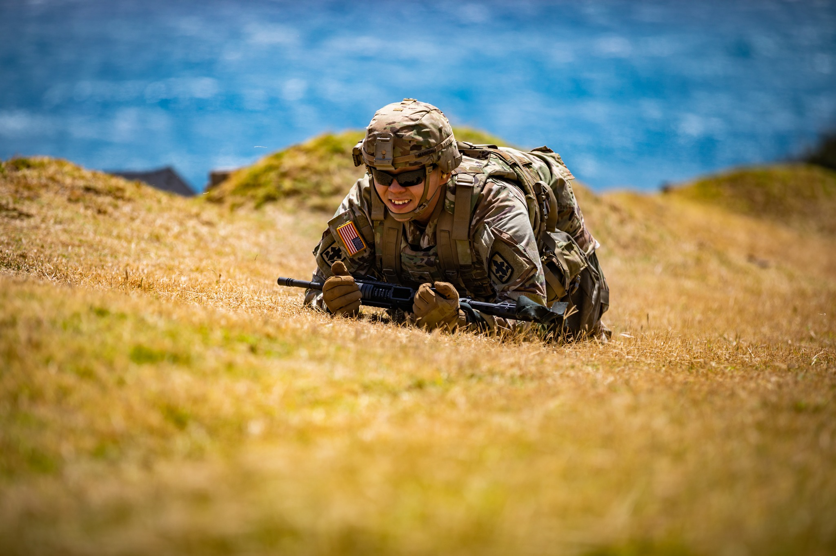
Sergeant First Class David Earle, an Officer Candidate with the Charlie company 29th Infantry Brigade Combat Team, Hawaii Army National Guard, participates in the stress shoot portion of the 2021 State Best Warrior Competition at Puuloa Rile Range, Ewa Beach, Hawaii April 1, 2021.​

“The stress shoot pushes Soldiers to zero and qualify with their assigned weapon while placed under physical and mental stress,” said Earle. ​More than 30 Soldiers of the Hawaii Army National Guard participated in the 2021 Best Warrior Competition March 31-April 3, 2021. ​

Photo by Spc. Ronald Bankole, 117th Mobile Public Affairs Detachment, Hawaii Army National Guard

Getting Published
After taking photos and writing captions, it’s time to get it to the next PA echelon. Be sure you understand who to send your photos to. ​Consider who has the release authority. During drill, annual training or exercises, it will be a higher PA element to give release authority​. ​During deployment brigade PA Office or higher PA elements may give release authority​.
To help share the National Guard story, submit 3-5 of your best photos with captions to Hawaii State PAO at least once a quarter. This will allow the photos and pictures to get published at a higher level, such as in the HIDoD Newsletter, TAG Instagram / X / Facebook, or local news.
An online drop-box has been set up on the State of Hawaii Dept. of Defense website for UPARs to drop photos and captions. The State PAO will receive that info, review and send back for use. If it does not meet publishing standards, it will be explained why. The State PAO can provide Release Authority for social media if UPAR is an Admin on any of the approved HING social media sites. For the HIARNG, currently it is: HIARNG main pages, Recruiting and Retention, Medical Detachment, 29th IBCT, 103rd TC, 298th MFTR.

Record Basic Video
There are many similarities when shooting photos and recording video, UPARs will be able to record video for social media and short clips of B-roll that can be used by higher PA elements for distribution. A video can be a standalone piece that is ready for publishing. While B-roll is usually a series of videos to be used as supplemental footage, that can be edited for a news story. B-roll is what other organizations can use to make a video news story. If media cannot attend, they rely on Public Affairs or HING UPARs to record and publish B-roll of an event​. Release Authority: All videos must be reviewed by a PAO prior to publishing anywhere.
Tips for shooting video:
- Keep individual shots 15 seconds or less
- Try to keep the camera still, tripod or “lean-to”
- Don’t zoom in or out, physically move or walk closer
- Watch the lighting
- Always record in landscape view (horizontal)
- Record from a variety of angles and distances
- Look out for people who may be video bombing the footage
- When recording don’t talk, watch sneezes and coughs and other
- Review the video before sending to others
- Before sending, ensure you are sending correct video
B-roll “package” should include:​
- Multiple videos less then 15 seconds in length
- Vary the videos angles through establishing shots, medium shots and close-ups​
- Have cut-aways which are the interruption of a continuously filmed action by inserting a view of something else.
- Cut-aways are close-up shots of the rank, a name on a chair, a flower decoration at the event … These are used to put in between shots. So instead of a close up of a speaker to long shot of crowd, it will be, close-up of speaker, a cut-away of a name on a chair, to long shot of crowd. It explains how the editor travels from one shot to another.

Media Escort and Preparation
Provide a media escort to reporters that visit your armory or training sites. Prepping the unit for the visit by preparing the Subject Matter Experts (SME) for interviews, finding locations to visit, and generating talking points. The UPAR will also ensure OPSEC is observed, but it is everyone’s responsibility. When the media arrives in a unit’s Area of Operations, the commander should be informed of their arrival and the UPAR should be the first to greet them and facilitate reasonable requests. The UPAR will be the unit’s representative to escort media. Coordinate with higher PA element about the media’s arrival, location, time on site, have parking available, the intent of the visit, talking points, and “no-go” areas.
Media Escort:
- Stay with media at all times​
- Rehearse the path​ the media will be taken on
- Upon arrival, give brief on status of unit and set some Ground Rules. Rules that unit has for the media.
- Ground Rules examples: interview to last 15-20 minutes, no questions on subject X, can only shoot new equipment from distance and not close-up.
- Post interview tasks for UPAR:
  - You can make on-the-spot corrections or give clarification​.
  - Think about how the interview went and what you could have done better​.
  - Ask media members when the story will be aired or published​.
  - Thank the reporter and exchange contact information.
Who speaks for a unit when a reporter wants to interview someone? The commander. A UPAR is likely to be very much involved in the process by providing support, but it is the commander who has the responsibility of being the spokesperson for a National Guard unit. This doesn't mean that a reporter can never speak to someone else in a unit. A situation might require that an SME regarding a piece of equipment talk with journalists, but the commander remains responsible. The commander can delegate this to the UPAR, but the commander is still the responsible for the content. This is something that can be planned when meeting with the commander and discussing the PA Plan for the UPAR: Who is or would be, the spokesperson for the unit. It really should be someone other than the UPAR.
Sometimes, a UPAR can't respond to a reporter's questions. Time is short, the question is too delicate or complicated, or you're not sure about the authority you have to discuss a certain situation. When that happens, the answer is to courteously respond, "I don't have any information for you. Let me check and get back to you". It provides you the opportunity to forward their question to your higher headquarters or the Hawaii State PAO.

Key points to remember:
- You represent the National Guard and the larger Military Service establishment (U.S. Army or U.S. Air Force) when you deal with journalists. Always keep your personal views and opinions out of the conversation.
- Begin with the attitude that a reporter represents the public, and the public has a right to know about the military.
- Avoid technical language, jargon and military acronyms. Be aware that few civilians have military experience.
- Keep your cool when under verbal fire.
- Don't automatically accept a reporter's facts or figures as correct.
- If you don't know the answer, say so. Offer to find the answer.
- Be early. Arrive before your SME, commander and the media for news media appointments. Talk to reporters before the interview about the subject points that are key to the story or that you would like to discuss.

Media Relations
Media Relations includes how we communicate with the media, interview prep and techniques to ensure we get our message effectively communicated. UPARs will learn how to use Public Affairs Guidance, command messages/talking points, and techniques for media interviews. UPARs will also provide the information needed by Hawaii State PAO for media releases and advisories. The UPAR will be the unit’s representative to escort media and tell its story to the public.
Working effectively with reporters, whether the news is good or bad, requires preparation and practice. If a serious incident takes place involving members of your unit, or something happens in your area involving HING property or equipment, work with your chain of command to ensure that the Hawaii State PAO is notified immediately. If an accident involves serious injury, death or significant loss of property, the moment you finish calling for help from the police and/or fire departments, begin the process of notifying proper PA Office.
By notifying the Hawaii State PAO immediately, you engage the horsepower of higher headquarters. Avoid the temptation to wade into a potentially complicated public affairs issue alone. Rely on the full-time PA Office to take over the public affairs mission and stand by to help.
A brief analysis of the relationship that the National Guard has with the media along with recommendations on how to make the most of all situations:
- Reporters have a job to do, their stories and pictures serve an important function in our democratic society. The first item in our nation's Bill of Rights deals with freedom of the press and which is a cherished freedom.
- Reporters have bosses to serve and often work in a competitive marketplace. To be successful, they must be accurate and fast. Their eagerness to work quickly doesn't always mesh with the military's careful way of doing business, but a smart UPAR can learn how to satisfy the media's requirements for speed and accuracy while at the same time protecting the best interests of the National Guard.
- Timing is everything. For TV media outlets, they like to be on-site for less than an hour as they must shoot and edit the video, write the story before the first newscast, which can be as early as 1700. If you back plan from there, they need to be at their station by 1400 or 1500 to work that story. Meaning your event needs to be done an hour prior. So, if you really want media to attend an event, make it early and convenient. Newspaper and web-based media have a little more flexibility.
- Reporters are eager to learn about new things, experience new situations and meet interesting people. All these factors contribute to their mission of informing the public. Harness this natural curiosity to your unit's advantage.
- It is important to keep in mind the spirit of a Department of Defense document called the Principles of Information. These published principles require that everyone in the military must maintain open, honest and fair dealings with civilian journalists.
- Information may not be withheld from a reporter who asks for it merely because the information may be embarrassing to the military. However, at any time if you or an SME questions what they can say in an interview, don’t say it, refer the question to Hawaii State PAO.
The Assistant to the Secretary of Defense for Public Affairs has the primary responsibility for carrying out the commitment represented by these principles. The Principles of Information are codified as enclosure (2) to Department of Defense Directive 5122.5 of Sept. 27, 2000. The Principles of Information are also available in a full-color, printer-friendly version signed by then Secretary of Defense Donald Rumsfeld.

Special Circumstances
On occasion, a unit commander or UPAR may find themselves responding to a reporter's questions that deal with accidents, criminal matters or political activity. You will want to turn the questions to your higher headquarters or the PA Office. In situations where you are waiting for assistance, here are suggestions to aid your efforts:
- When accidents happen, especially if there are major injuries or a death, you can count on being contacted by reporters. While proper military authorities are getting involved, the UPAR should swing into action by gathering accurate information about the accident. This information becomes the basis of a statement that can be forwarded to your full-time PA Office so they can take the lead and begin responding to reporters. Often, you may have to work in cooperation with local civilian law enforcement authorities or rescue personnel. Two important things to remember:
  - Names of dead or injured victims must not be released until the victims' next of kin have been properly notified. Use this statement: "The names of the victims are being withheld pending notification of next of kin."
  - Do not speculate about the cause of an accident, an investigation will determine the cause. Don’t deny the obvious, for example if an aircraft has crashed and burned, say that a crash and fire have taken place, don't speculate as to the reasons why.
- Reporters may call your unit for information about a person who may be suspected of or charged with committing a crime. The event may or may not involve the military or the person's affiliation with the National Guard. When this occurs, you need to work quickly and carefully to alert your higher headquarters and the full-time Hawaii State PAO. These people have the responsibility to prepare any media statements.

Different Types of Media
The way people get their news has drastically changed in the last 30 years, from printed newspapers and radio broadcasts to social media and podcasts. The information consumed today leans heavily towards digital platforms and social media. Digital platforms can be YouTube-based, podcasts, or only found online or on social media. Today’s media are often looking for a dynamic video and quick soundbites on interesting topics.
Media is looking for:
TV | They want a great video; it can be provided during visit, or you can have b-roll already up on DVIDS​.
Radio | They want some natural sounding sound bites and a good interview
Newspaper | They want one or two great pictures of action that matches the story​
Digital | “Click bait” quality video or headlines

Sound bites form interviews and are only about 10 seconds of a quote from one person. The media may interview three guardsmen for five minutes each, but they will use only one bite. That bite will need to match their theme or angle of a story. Try to anticipate what their theme or angle is, you can usually tell from the types of questions they are asking. Prep the interview subjects on the angle ahead of time.
You can successfully communicate with the public and have more positive control of an interview situation with:
- Knowledge of your subject
- Honesty
- A positive attitude
- The use of concise, simple language
- Familiarity with the media
- Preparation
- Asking a PA professional

Public Affairs Guidance
The development of a well prepared and coordinated public affairs guidance can be your most valuable tool. Public Affairs Guidance or PAG, is a plan for action or plan for defense. PAG is created for large events by PA Specialists or Officers. It contains themes, messages, talking points and possible questions and responses​. UPARs may be able to get PAG from their commanders for large exercises or real-world events. UPARs will need to ask for these, they will not be pushed to UPARs.

Sample Public Affairs Guidance Q&A
Q1. What is the purpose of Exercise Tiger Balm? ​
A1. The purpose of Exercise Tiger Balm is to heighten the professional relationship, combat readiness and interoperability between the U.S. Army and Singapore Armies, which demonstrates our commitment to our partnership, regional security and a free and open Indo-Pacific.

Command Messages/Talking Points/Themes
Command Messages are positive points the leadership want the public to remember and ensures the story being told is not simply about one issue, but the “big picture” to what the Hawaii National Guard does to help and serve the community. They are usually one sentence and may come from a variety of sources, including a Commanding Officer, a Public Affairs Officer, the PAG, and higher headquarters.
Themes are unifying ideas or intentions that support the narrative and are designed to provide guidance and continuity for messaging and related products. Themes link groups of messages together and are generally one to two words.
Command Messages support themes by delivering tailored information to a specific stakeholder or public and can also be tailored for delivery at a specific time, place, and communication method. Messages are everywhere. They are used in every communication product and anytime you address your stakeholders and publics. An effective answer is combining a Command Message (theme related) and a Talking Point (fact). It takes practice to smoothly weave CMs and Themes into answers.
Talking points, also referred to as secondary messages, are concise, releasable statements of fact within the limits of a command’s authority that provide support for your message and are relevant to your stakeholders. They are interesting and useful points that relate to the message that stakeholders and journalists find useful. Depending on the situation (deployment, ceremony, accident etc.), the PAO will write talking points accordingly and ensure they are disseminated to the appropriate level.
Themes, messages and talking points statements should be used in every engagement or conversation applicable to the key publics and stakeholders. Your theme is only one to two words that describe an overarching idea or message. Your messages provide context and support for the theme. Your talking points support the message with facts. There may be more than one theme for every objective and there should be 2-3 messages for every theme.
Command Messages Examples
Command Message | The men and women who make up this unit served with distinction, despite hardships and loss.
Talking Points | We lost 12 members to combat actions, four to non-combat related deaths, and 124 were wounded supporting our missions.
 | We earned nine Silver Star medals, a Presidential Unit Citation, nine Joint Meritorious Unit awards.
Command Message | We are invested in the process of returning our service members from a combat to a home environment successfully.
Talking Points | One of the programs offered at Joint Base Parker-Truscott is the “Service member and Family Life Consultants Initiative,” which offers free anonymous reunion and reintegration support to service members and their families.
 | Before returning home, service members will attend communication and stress management workshops developed to help them transition back into their communities.
Command Message | JTF Wolverine service members are professionals who are committed to their country and mission.
Talking Points | The 76th Brigade, the largest unit in the Indiana Army National Guard, trained for 6 months for this deployment, and was able to provide essential reconstruction projects in Kandahar City province.
 | There are 5,000 sailors and Marines comprising the Bonhomme Richard ARG, which consists of the flag ship, USS Bonhomme Richard and embarked Marines of the 15th Marine Expeditionary Unit.

Hints For Media Interviews
- Know as much as possible about the subject. Don't guess at an answer or respond to hypothetical questions. If you don't know an answer, say so.
- Be aware of your speed in talking — not too fast, not too slow. Regional accents and dialect add interest to broadcast stories, so don't let this be a barrier to someone being interviewed. At the same time, the interviewee must be able to communicate clearly and effectively. Watch for acronyms, low volume, and pidgin-heavy accents. Do not pick someone who does not like to talk, find someone else.
- Gestures and mannerisms can be very distracting. Be careful what you do with your hands, legs, and facial gestures.
- Wear the proper uniform and wear it correctly. If you're in a studio, Class A is likely to be appropriate. If you're in the field, match what the troops are wearing. Be alert that proper safety gear and other uniform items are worn correctly, especially when in a field environment. At the same time, don't interrupt an interview if you notice an unfastened button or something that the civilian audience won't notice as being out of regulation.
- Rehearse what you want to say with someone who asks you questions, especially the tough ones you might expect.
- Be on time for interview appointments. If you're the guest on a call-in show or other live interview, the station is counting on you to be on their program.
- Put your conclusion into the front of your interview remarks, then expand on the topic.
- Speak in short, effective sentences. Long answers are seldom used. The more you talk, the more chance of saying something that can be misunderstood.
- Stop talking when you've made your points.
- Stay "on the record." Don't say anything outside the interview you wouldn't want to see or hear in the news. Don't agree to respond "on background" or go "off the record" with a reporter.
- Most reporters are generalists. You are the expert on military matters. Do not be timid if you have an opportunity to educate a reporter about military issues.
- Be polite, professional and sincere.
- Prepare for interviews. Know the talking points that you want to make and remember why you were asked, for the interview.
- Establish ground rules and subject matter to be discussed prior to the start of a formal interview.
- Do your homework. Practice talking about the subject with someone who will ask you questions, especially the difficult questions. Even in your specialty, a brush-up is wise.
- Call on your full-time Hawaii State PAO for assistance.

Command Information
A method of communicating mission essential information to members of the command. The UPAR should be prepared to cover unit participation in community projects, promotions, award ceremonies, changes of command and many others. All these events can potentially be shared on social media, newsletters or posters/flyers. What gets covered should be established with the commander when the UPAR develops the unit’s PA Plan. Command Information aids internal command cooperation and mission performance​. In addition, it keeps members of the command informed, helps improve quality of life, promotes morale and fosters career retention​.
Important events:
- Community projects
- Promotions
- Award ceremonies
- Changes of command/responsibility
- Re-enlistments
- Yellow Ribbon events
- Retirement ceremonies
- FRG events
- Holiday functions
Command information could be presented as:
- A newsletter
- On an official social media site
- A flyer
- A briefing
- A bulletin board
- An internal slideshow or collage
There is another audience of people who must be reached if you are to have an informed and capable unit. It is the military family’s in many instances they are not only the most difficult to reach with your message, but the most important. They have a lot of sway on our members and their perception of our operations and routine missions are important.
Part of the difficulty in contacting or keeping this audience informed is recognizing the importance of an effective, local-level command internal information program which uses a variety of methods to reach both the members of your unit, and their families.
Critical to maintaining support from a Guard member's family is to ensure they understand what is going on in the unit and how that is important to the welfare of Hawaii and the defense of our nation. The key word is "understand," and for family members to continue to understand and support participation in the Guard. They need to be informed of the reasons why the Guard is important and why the contribution is necessary. This is something that the commander needs to consider. It should be discussed at the initial UPAR/Commander PA Planning meeting. Effectively communicating with the military families is not the sole responsibility of the UPAR. However, the UPAR can be a tool or resource that the commander can use to reach that audience.

Unit Newsletter
One of the best ways of reaching your members and their families is with a regular unit newsletter. Your newsletter is a close-to-home publication and should be much more informal. UPARs can assist, but newsletters are not something UPARs are trained to produce from cradle to grave. UPARs can provide content for newsletters. Listed below are some newsletter tips, but it should be a unit responsibility. The UPAR can be a part of that working group that oversees a unit newsletter.
The unit newsletter should include:
- Comments from the commander and senior NCO on what they want to emphasize for the upcoming training periods.
- Latest promotions and awards given to members.
- Dining hall menus and other "nice to know" information that keeps everyone in the loop.
- News related to family such as information about the PX or BX, commissary, pay, benefits and up-coming events.
- Important telephone numbers and drill schedules.
- Pictures with captions.
- Current events from Big Army, NGB, NGAUS, HING.
How to create a newsletter
The real key is the dedication of the UPAR and the commander to ensuring the newsletter includes good information, is produced consistently, and is clearly backed by the commander. It is not the responsibility of the UPAR to start and maintain a unit newsletter. Ask if there is a template you can use. Don’t recreate the wheel if you do not have to.
- Word, Canva, and other programs contain templates for newsletters. Try one of these for starters and modify it for your needs.
- Keep it simple. Look at the newsletters of schools, clubs and other units for examples.
- Be careful with what your newsletter says. Avoid the temptation to be too cute or clever.
- Keep your higher headquarters informed about your newsletter. Include them on your distribution list.
- Plan ahead. If your unit holds an awards ceremony each quarter, plan your newsletter to coincide with the ceremony.
- Be consistent. Members and their families will come to depend on your publication for important information.
- Ask for help when you need it. Seek assistance from higher PA elements or Hawaii State PAO.

Social Media
Social media gives people the ability to communicate with larger audiences faster and in new ways. It has become an important tool for messaging and outreach. There are a variety of social media platforms ranging from text, audio, imagery and videos; all of which are generated and maintained by organizations and individual members.
Soldiers and Airmen have always been the National Guard’s best and most effective messengers. Social media enables the National Guard Family to stay connected around the world and is a powerful communication tool. Before you get started with social media it is important to understand the required policies and resources available. Any unit may have unofficial accounts that are closed or private, they can be groups, they must not be open to the public and labeled unofficial. Select units may have official social media accounts (see below list). These accounts require review by a public affairs officer. Units without accounts will submit photos and captions to the higher PA element for posting on the approved social media accounts.
There is social media training provided by the Hawaii State PAO that explores this topic in more detail. The training highlights social media policy​, how to register official accounts with PAO, create a social media plan​, rules of engagement​, what PAO can do for you, as well as some social media strategies. Before taking over an existing account contact the Hawaii State PA Information Specialist III at 808-369-3517 to sign up.
Approved Social Media Accounts:
- Hawaii Army National Guard
  - https://www.facebook.com/HIARNG
  - https://www.instagram.com/hawaiiarmynationalguard
  - https://www.linkedin.com/company/hiarng
- Recruiting and Retention Battalion
  - https://www.facebook.com/HawaiiNationalGuard
  - https://www.instagram.com/hi_armynationalguard
- Medical Readiness Detachment (MRD)
  - https://www.facebook.com/hiarngmeddet
- 29th Infantry Brigade Combat Team:
  - https://www.facebook.com/LavaBrigade/
  - https://www.instagram.com/29thinfantrybrigade/
- 103d Troop Command:
  - https://www.facebook.com/103DTC/
- 117th Mobile Public Affairs Detachment
  - www.facebook.com/117MPAD/
  - www.instagram.com/117mpad/
- 298th Multi-Functional Training Regiment (298th MFTR)
  - www.facebook.com/298thFRG

8.Writing the Story
Learn the basics of writing a news story and a feature story. In addition to understanding what is newsworthy and should be sent higher for release, what should be published at the unit level. Getting roughly 75% of a final product story and forwarding it on Hawaii State PAO is great. Don’t worry about perfect grammar or formatting- worry about other content: the 5Ws, some quotes, facts about event… Stories can be marketed and shared in many places. They are gold to a higher level Public Affairs elements.
When writing a story some key points to remember are:
- Use short, familiar words
- Use short sentences and short paragraphs
- Eliminate unnecessary words
- Avoid statements of opinion
- Avoid overloading sentences with unrelated ideas
- Use relatively simple sentences that follow normal word order: subject-verb-object
- Write consistently
- Use action verbs
- Keep modifiers near the things they modify
- Use specifics rather than generalities
- Limit sentences to 25-30 words each

News Story
News stories are written using the inverted pyramid, which consists of the lead, the body and the tail. The lead is the essence of what you know about the event, it draws the reader into the story. The bridge is second paragraph of a news story consisting of one sentence, with 30 words or fewer. The tail expands on the lead and transitions from the bridge to the body of the story; provides the “tie back” and secondary facts.
Inverted Pyramid
The inverted pyramid allows for writing under deadline, and it gives editors the flexibility to cut the story from the bottom up without losing any essential facts. The primary advantage of the structure is that it allows someone to stop reading a story after only one or two paragraphs yet still learn the newest, newsworthy, and most important facts.
The Lead: the most important information | Who? What? Where? When? Why? How? | 1-2 thin paragraph
The Body: the crucial information | Argument, controversy, story, issue | Evidence, background details, logic etc.  Quotes, photos, video and audio that support, dispute, expand the topic
The Tail: Extra information | Interesting/related items | May include extra context in blogs, columns and other editorials: the assessment of the journalist.

News Story Example
Honolulu, Hawai‘i- Honolulu Police charged a 29th Infantry Brigade Combat Team Soldier, with the cloning of his spouse, after an argument.​

Spc. Kimo Tavati Makanani was charged Jun 4 with the cloning of 25-year-old Puanani Makanani, who was found cloned in their Pearl City home Jun. 13 after concerned family members requested a welfare check, according to an Army news release put out by the 29th Infantry Brigade Combat Team.​

"Our brigade and the Hawai‘i National Guard community are shocked by Makanani’s cloning," Col. Kenny Raha, commander of the 29th IBCT, said in the release. "We have extended our support for the clone and ‘original’ to the Makanani ‘ohana.”

The Lead
A lead is the first few sentences of a story. It is the most critical element of a story. A lead grabs attention and starts the flow. A lead also tells something about the subject of the story and shows the story’s significance. It answers the question “So what?” Your leads should contain the five W’s and H.
Readers can ask six general key questions about an event: who was involved, what happened, when did it happen, where did it happen, and why and how? One of the five W’s or H is usually more important than the others. In general, the lead emphasis of most news stories is the “who” or the “what.”
- The “Who” element may be a single person, a group of people or an organization. When the story is about a single person, it is important not to use the person’s name unless the person is prominent. For people who aren’t well known or when there are several persons to be identified, another form of identification is more meaningful. One of the best ways to identify a person who is not well known is to use the person’s job title and unit. The person’s full identification will be revealed in the bridge of the story.
- “What” tells briefly what happened at a planned or unplanned event. The key is to be brief and get to the point. The most common order for a summary news lead is “who did what.”. However, there may be times when you may want to begin the lead with the “what” element. Here is an example of when the “what” element might be the lead emphasis: A free, public concert by the U.S. Army Band is scheduled for Friday at the parade field here. The fact that the concert is free will draw the attention of your readers.
- The “Where” gives the location of the news event. This question need not always be answered in specific terms. “Here” often is sufficient for an event happening on post. Here’s an example: Soldiers here and across the Army will see an increase in their basic housing allowance next month since Congress approved an increase of 3 percent today. A lead may need more than one “where” for clarity. Here’s an example: A maintenance technician with the 5th Battalion, 7th Air Defense Artillery Regiment was named the McCarthy Leadership Award winner Tuesday at the Basic Leadership Course at Rose Barracks, Germany.
- “When” is the time or date of an event. The question of “when” does not need be answered in specific terms. Often it can be vague as “this morning” or “today.” How specific depends on how important the time element is to the story. It’s important to use such words as scheduled, planned, or slated when writing about events that will take place in the future.
- The “Why” concerns the cause of an event, and it is frequently implied or unavailable. Sometimes it may be used in the bridge of the story. Here’s an example: A Basic Still Photography course instructor at the Defense Information School here was named the school’s Junior Service member of the Quarter today at the school for his military bearing and knowledge of current military events. This lead contains the four required W’s and the “why.”
- “How” relates the circumstances or the manner in which something in the story is accomplished. When it is present it often provides an intriguing lead. Here’s an example: A student at the Defense Information School here saved the life of one of his instructors today at the school by using cardiopulmonary resuscitation skills he learned last week.
The Bridge
After writing a news lead, the writer looks over the facts to decide what items will be in the bridge. A bridge paragraph is a means of transition from the summary information in the lead to the detailed information of the body. It is the second part of a straight news story and is one sentence, 30 words or less. It expands on the information in the lead. The bridge can serve one or more of five major functions, depending upon the lead.
- The first function is to add any of the five W’s or H which were not included in the lead. Take a look at this example of a bridge that displays this function:
Lead | A former post garrison commander is scheduled to become the 25th commanding general of Fort Meade, Tuesday in a change-of-command ceremony on the post parade field.
Bridge | Brig. Gen. James F. Holingsworth will succeed Maj. Gen. John T. Hockings, the post commanding general for the past two years, who is retiring to Virginia after a 28-year Army career.
- Another function of the bridge is to provide attribution to the statements in the lead. Attribution gives the source (who said it) or authority (directives, regulations, sources, etc.)
- A third function of the bridge is to provide complete identification after a lead. Complete identification means service (if needed), rank, full name, age (if needed), job title or occupation, and unit or organization.
- Tie-back a fourth function of the bridge is to give the reader a recap to an earlier story on the same subject. The writer must never assume his readers have read the first version of the story. Therefore, a tieback is necessary to put the readers in a proper perspective.
Lead | Two soldiers were apprehended here today as suspects in Tuesday's post bank robbery.
Bridge | The suspects were taken into custody after allegedly trying to pass some of the $18,000 in marked currency taken from the bank at gunpoint, said Barney N. Carl, the post provost marshal.
- The final function of the bridge is to bring out additional information that is not in the lead but further explains the lead.
Lead | Nine classrooms at the Defense Information School here were vandalized when the school was broken into over the weekend.
Bridge | More than 100 desks were piled into the middle of the second-floor west hallway, and vandals spray-painted “Long Live Fall Out Boy” on the walls of the classrooms, said Barney N. Carl, the post provost marshal.

Body
The remainder of the story is written in descending order of importance. The functions of the body in a news story are to expand on information given in the lead and bridge. Additional facts are typically listed in diminishing order of importance.

Feature Story
A feature story is a factual story that is not hard news but is instead a more personal report about a person, event, or aspect of a major event.​ Writers must incorporate facets of writing often not found in news stories — ones that are often associated with fiction writing, including description, a greater use of quotes, anecdotes, and sometimes extensive background information.​
Elements of a feature:
- Explore topics or issues of currency and importance
- Research and planning
- In-depth
- Clear and concise sentences
- Header/title
- Lead/introduction
- Bridge to link the lead to the body
- Body (show don’t tell)
- Quote
- Conclusion command message or quote
Feature Story Example
The Hawaii National Guard’s State Partnership Program (SPP) is in full effect with Lt. Col Johnny Johnson, Bilateral Affairs Officer (BAO) hard at work planning, coordinating and synchronizing formal and informal military-to-military and military-to-civilian, virtual and in-person engagements.​

BAOs facilitate regular contact with their assigned Partner Nation (PN), which is a key component for building and enduring relationship.

The BAO program is administered by the National Guard Bureau, guided by State Department foreign policy goals, and executed by the state adjutants general in support of the security cooperation objectives of the regional combatant commander and the U.S. Chief of Mission of the partnered country.​

Bilateral Affairs Officers are members of the Army or Air National Guard on Title 10 (active duty) orders assigned to an embassy to assist the state in managing and executing requirements associated with the State Partnership Program.

UPAR VS PA Specialist
UPARs are not PA Specialists or Officers. However, they can assist the PAO elements within the chain of command​. The UPARs main goal is to take a photo and write a caption, everything beyond that is a bonus. PAO elements appreciate the UPAR’s time and effort put into the role. UPARs should learn as much as possible, but they can always reach out to the PA Office for help. The UPAR role is valuable to the commander and can help make the unit a better place. Commanders should protect their UPARs from mission creep and not pile on every communication idea on them.
What does a UPAR do:
- They create a public affairs plan with their commander​.
- They are the liaison between the unit and higher PAO elements.
- They take photos and write captions, which is their most important responsibility.
- They may have to escort reporters​.
- They may be a unit spokesperson​.
- They may occasionally write stories​.
- They can help find talking points and command messages.
- They do not conduct public affairs training.
- If the UPAR has time, UPARs can assist with: ​
  - Static displays​
  - Unit histories
  - Unit newsletters
  - Prep Spokespersons
What does a PA Specialist do:
- They plan and execute TAG’s and higher PA objectives​.
- They provide PA support to newsworthy events, usually BDE or higher​.
- They take photos, writes captions and stories, post to DVIDS​ in a timely manner.
- They facilitate engagements with media, takes all bad news​ and can prep the SMEs.
- They prepare media releases, media advisories, and spokespersons.
- They create stories, shares photos, and captions on social media​.
- They can compose talking points and command messages​. They help write the PA annex for operations and exercises.
- They do the initial engagement with the media and respond with effective and approved messaging.
- They are honest and share the good and bad news. “Maximum exposure. Minimum delay.”

Getting Support
The 117th Mobile Public Affairs Detachment in the 103rd Troop Command or the Brigade PAO in the 29th IBCT or the Hawaii Air National Guard’s 154th Wing PA shop can provide:
- Support to the state's overall public affairs program
- Support to National Guard units
- News release support to newspapers, television and radio stations
- Still photo support and video capability
- Media escort
- SME Prep
- Train non-PA units on basics of PA
- On-site assistance during emergencies
- Support for production of a statewide National Guard newspaper, magazine or the website
The Hawaii State PAO should be able to assist you with the following:
- Assistance to units large and small
- Coordination of a public affairs support plan for your unit's annual training
- Conduct training for the UPAR, track all unit UPARs
- Publish a statewide newspaper, magazine or web pages
- Speech writing for leaders
- Media plan, media research, media visits
- On-site public affairs support during an emergency
- Consult on quality of work
- Hold Release Authority for social media posts

Contact Info
Hawaii Public Affairs Office
Mainline: 808-441-7000
Director, Public Affairs  Maj. (Ret.) Jeff Hickman | jeffrey.d.hickman@hawaii.gov | 808-369-3518
Public Affairs Specialist  Ms. Rachel Blaire | rachel.s.blaire.civ@army.mil | 808-369-3520
Information Specialist III  Mr. Ruben Duldulao | ruben.duldulao@hawaii.gov | 808-369-3517
Photojournalist/Videographer  MSgt (Ret.) Andrew Jackson | andrew.l.jackson@hawaii.gov | 808-369-3521
Joint Operations Center (JOC)
Public Affairs  VACANT |  | 808-733-4263
Recruiting & Retention Battalion (RRB)
Public Affairs  CPT Clayton D. McNair | clayton.d.mcnair.mil@army.mil | 808-672-1330
Headquarters 154th Wing (154WG)
Public Affairs  MSgt Mysti Bicoy | mysti.bicoy.1@us.af.mil | 808-789-0419

Social Media Accounts
- Hawaii Adjutant General
  - https://www.facebook.com/taghawaii/
  - https://twitter.com/HawaiiTAG
  - https://www.instagram.com/tagofhawaii/
- Hawaii National Guard Command Senior Enlisted Leader
  - https://www.facebook.com/HawaiiNationalGuardSeniorEnlistedLeader/
- Hawaii Deputy Adjutant General
  - https://www.facebook.com/daghawaii
- Hawaii Army National Guard
  - https://www.facebook.com/HIARNG/
  - https://www.instagram.com/hawaiiarmynationalguard/
- Hawaii Air National Guard
  - https://www.facebook.com/hawaiiairguard/
  - https://www.instagram.com/hawaiiairnationalguard/
- Hawaii Army National Guard Recruiting
  - https://www.facebook.com/HawaiiNationalGuard/
  - https://www.instagram.com/hi_armynationalguard/
- Hawaii Army National Guard Retention
  - https://www.instagram.com/hiarng_hana_hou/
- Hawaii Army National Guard Education & Incentives
  - https://www.instagram.com/hiarng_education/
- Hawaii Army National Guard Officer Strength Management
  - https://www.instagram.com/hiarng_osm/
- Hawaii Army National Guard Military & Family Readiness Specialists
  - https://www.facebook.com/HIARNGmfrs
- Hawaii Air National Guard Recruiting & Retention
  - https://www.facebook.com/HIANGRecruitingandRetention/
- Hawaii Air National Guard Recruiting
  - https://www.instagram.com/hawaiiairguardrecruiting/
- Hawaii Air National Guard Airman & Family Readiness Program
  - https://www.instagram.com/hiairmanandfamilyreadiness/

Associated Press Rank Abbreviations
Enlisted Ranks |  | Commissioned Ranks
PVT  PV2  PFC  SPC  CPL  SGT  SSG  SFC  MSG  1SG  SGM  CSM  SMA | Pvt.  Pvt.  Pfc.  Spc.  Cpl.  Sgt.  Staff Sgt.  Sgt. 1st Class  Master Sgt.  1st Sgt.  Sgt. Maj.  Command Sgt. Maj.  Sgt. Maj. of the Army | 2LT  1LT  CPT  MAJ  LTC  COL  BG  MG  LTG  GEN | 2nd Lt.  1st Lt.  Capt.  Maj.  Lt. Col.  Col.  Brig. Gen.  Maj. Gen.  Lt. Gen.  Gen.
 |  | Warrant Officers
 |  | WO1  CW2-5 | Warrant Officer 1  Chief Warrant Officer 2-5

Additional Duty Appointment Sample Memo

NGHI-TAG 29 April 2021

MEMORANDUM FOR RECORD
SUBJECT: Area of Special Emphasis (Additional Duty Appointment) – Public Affairs
Representative (UPAR)

- Effective 1 May 2021, the below named individual(s) is appointed as indicated:
  - Primary: HARRINGTON, THADDEUS G., SSG, 117TH MPAD
  - Contact: 808-369-3520, Thaddeus.g.harrington.mil@mail.mil
- AUTHORITY: AR 360-1, Para 2-3
- PURPOSE: To assume the responsibilities for the administration of the unit’s public affairs program, providing support to the commander IAW the HIARNG UPAR Handbook, AR 360-1, and NG PAM 360-5.
- PERIOD: Until officially relieved or released from appointment.
- SPECIAL INSTRUCTIONS: Capture, publish, and submit captions, photos and videos relevant to the unit missions. Individual(s) will become familiar with applicable regulations(s), attend yearly UPAR training event, and perform duty as required. This duty appointment supersedes all others.
- POC for this action is SFC Michael Johnson at XXX-XXX-XXXX, Michael.j.johnson@mail.mil

KIPP J. WARD
LTC, FA HIARNG
Commanding

DISTRIBUTION:
1 – Individual Concerned
1 – Addl Duty Binder
1 – Unit File
1 – Brigade EOA

